Implementing 0x20 to Harden DNS Against Poisoning Attacks

Objective
Certain DNS servers might be vulnerable to poisoning attacks. Despite the fact that you are free to propose any defense solutions, those designs that are compatible with existing protocols are most likely to result in immediate deployment. Through this project, students will

- Gain in-depth understanding of DNS protocols and the 0x20 algorithm.
- Investigate a concrete example where the good design can simplify the implementation process and minimize engineering efforts.

Environment
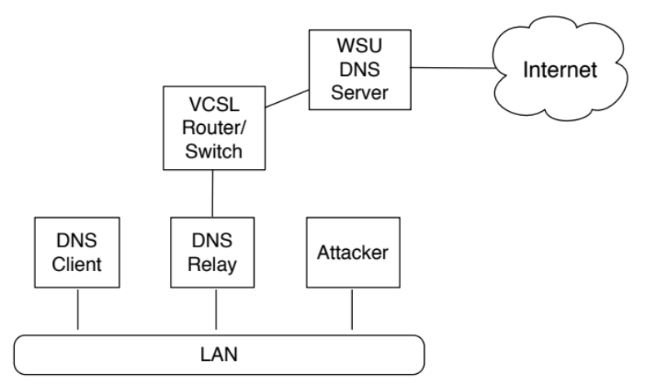

We will reuse the environment for Project 2. Three computers are located in the same LAN, including the DNS Client, DNS Relay, and the host used by the attacker, respectively. The DNS relay is not a recursive DNS server. Specifically, it behaves as a relay – receiving the DNS request from a DNS client, parsing it, and generating a new DNS query to a real recursive DNS server. In this specific case, the real recursive DNS server is the “WSU DNS Server”. Despite its simplicity, the DNS relay does implement the cache mechanism. Therefore, it is vulnerable to the poisoning attacks.

As all three computers are in the same LAN, the attacker’s computer can also receive the DNS requests generated by both the client and the DNS-Relay. However, in this project, we assume that the attacker cannot receive packets sent from the client and DNS-Relay. The attacker only knows when the client sends the DNS request and the domain name contained in this request.

We have given the DNS relay system, DenisDNS and its source code (licensed under the BSD license) to you. You can start the DNS system using the following command:

[sudo] java -jar DenisDNS.jar [-s ServerIP] [-p port]

This must be done in the directory with DenisDNS. Running it with sudo or other means of acquring root will allow it to reserve the standard port 53 for a DNS server, otherwise it will default to port 23456 (which will work, but necessitates using that port with any attempt to interact with the server). '-p port' specifies another port for it to run on. '-s ServerIP' lets you specify the DNS server it queries, otherwise it will check '/etc/resolv.conf' to get the one in use on your machine (and fail on Windows.)

After the DNS relay starts to work. You can go to the DNS client and then run the following command:

dig @DNS-Relay-IP:Port www.google.com

This command means that the DNS client uses the DNS-relay to resolve the domain www.google.com. The Port is the port number that the DNS relay is listening to. After DNS-Relay receives this request, it will parse it and extract the domain name, and then create a new DNS request. DNS-Relay will use its default recursive DNS server (WSU recursive DNS server) to get the IP for this domain. After the DNS-Relay gets response from the WSU recursive DNS server, it will return the result to the DNS client and meanwhile cache the result. Next time, if another client issues DNS query through DNS-relay, the cached result will be returned to that client.

Building
Included is the DenisDNS source code, set up as an Eclipse project ('denis-dns').
If you wish to edit either of these in the Eclipse IDE, you can download and install Eclipse (from https://www.eclipse.org/downloads/, (the basic Java version) or as packaged by your linux distribution of choice).

From there, you can import the project with:
1. Select File->Import.
2. Select General, and then Existing Projects into Workspace
3. Hit “Browse” in the “Select Root Directory” option and select the base directory of the project (the “denis-dns” folder).
4. Hit Finish. The project should be automatically configured to compile.

In order to set the command line arguments for the project to run or debug it in Eclipse, right click on the project, select “Run As” and then “Run Configuration”.
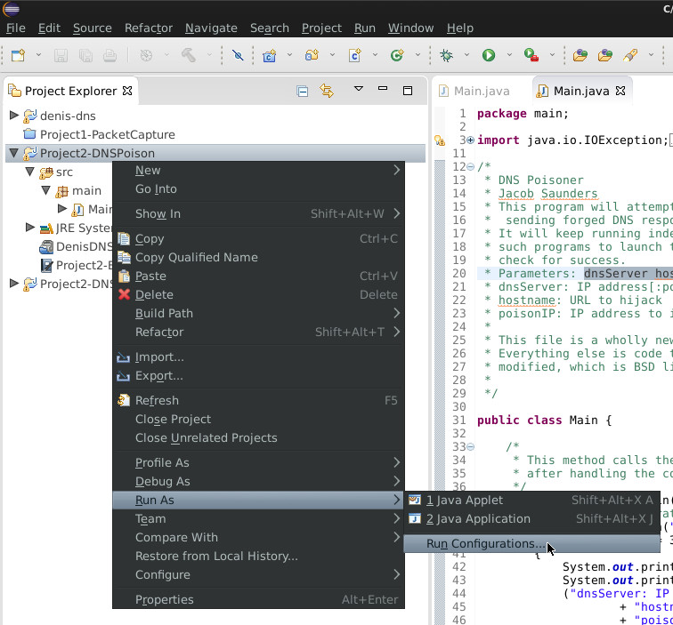
Select the arguments tab and enter the command line arguments for the program into the program arguments field, then hit apply.
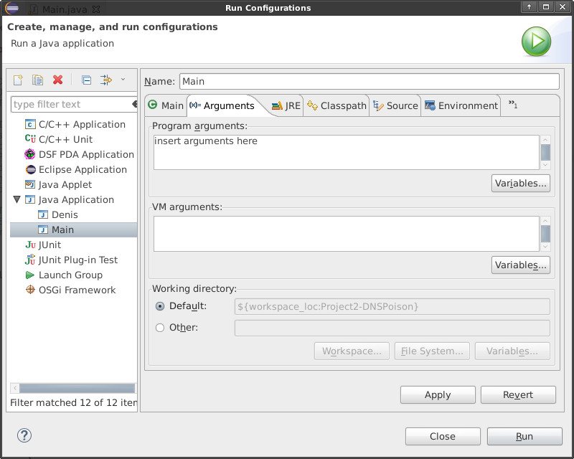

Task

You are required to modify the source code of the DNS-relay to incorporate the 0x20 algorithm.

Specifically, when the DNS-relay receives a DNS request from a client, it will randomly use upper or lower letter for each char in the domain and then forward it to the recursive DNS server.

In this project, you will only need to concern the type A DNS record.

Hint: The main method that Denis-DNS uses in order to recive queries from users is the DnsServer.run() method's 'while(true)' loop. You'll need to modify things in that or called from that.

Submission
Your submission will include:

- The source code of the system.
- A report that illustrates how you implemented the system and where you made the change.
- A manual that illustrates how we can compile your code and run your system. You should give some examples to illustrate the usage of your system.
It is worth noting that if your manual is not comprehensible and therefore we cannot successfully compile/run your code, you will lose score for that.

Licensing
DenisDNS, which is both packaged with this as well as code from it being used in the sample framework is licensed under the three-clause new BSD license:
BSD Licensed: Copyright (c) 2010, Trent Z. All rights reserved.
Redistribution and use in source and binary forms, with or without modification, are permitted provided that the following conditions are met:
- Redistributions of source code must retain the above copyright notice, this list of conditions and the following disclaimer.
- Redistributions in binary form must reproduce the above copyright notice, this list of conditions and the following disclaimer in the documentation and/or other materials provided with the distribution.
- Neither the name of the DenisDNS project nor the names of its contributors may be used to endorse or promote products derived from this software without specific prior written permission.
THIS SOFTWARE IS PROVIDED BY THE COPYRIGHT HOLDERS AND CONTRIBUTORS AS IS AND ANY EXPRESS OR IMPLIED WARRANTIES, INCLUDING, BUT NOT LIMITED TO, THE IMPLIED WARRANTIES OF MERCHANTABILITY AND FITNESS FOR A PARTICULAR PURPOSE ARE DISCLAIMED. IN NO EVENT SHALL THE COPYRIGHT HOLDER OR CONTRIBUTORS BE LIABLE FOR ANY DIRECT, INDIRECT, INCIDENTAL, SPECIAL, EXEMPLARY, OR CONSEQUENTIAL DAMAGES (INCLUDING, BUT NOT LIMITED TO, PROCUREMENT OF SUBSTITUTE GOODS OR SERVICES; LOSS OF USE, DATA, OR PROFITS; OR BUSINESS INTERRUPTION) HOWEVER CAUSED AND ON ANY THEORY OF LIABILITY, WHETHER IN CONTRACT, STRICT LIABILITY, OR TORT (INCLUDING NEGLIGENCE OR OTHERWISE) ARISING IN ANY WAY OUT OF THE USE OF THIS SOFTWARE, EVEN IF ADVISED OF THE POSSIBILITY OF SUCH DAMAGE.

